**Basic Scheduling**

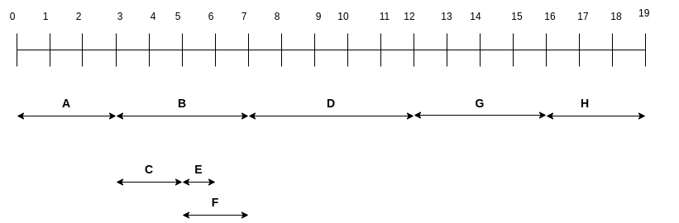

* delivery date After 19 days from the start
* duration is 19 days
* Tasks that can be delayed: E, F, C